**Pizza Sales SQL Queries**

**KPIs**

**Total Revenue**

SELECT SUM(total_price) AS Total_Revenue FROM [Pizza_sales].[dbo].[pizza_sales];

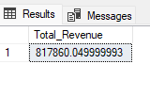

**AVG total value**

SELECT (SUM(total_price) / COUNT(DISTINCT order_id)) AS Avg_order_value FROM [Pizza_sales].[dbo].[pizza_sales];

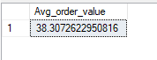

**Quantity Sold**

SELECT SUM(quantity) AS Quantity_Sold FROM [Pizza_sales].[dbo].[pizza_sales];

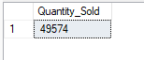

**Total Orders**

SELECT COUNT(DISTINCT order_id) AS Total_orders FROM [Pizza_sales].[dbo].[pizza_sales];



**avg pizza per order**

SELECT CAST(CAST(SUM(quantity) AS DECIMAL(10,2)) /

CAST(COUNT(DISTINCT order_id) AS DECIMAL(10,2))

AS DECIMAL(10,2)) AS avg_pizza_per_order FROM pizza_sales;

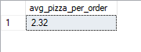

**Daily trend for pizza orders**

SELECT DATENAME(DW, order_date) AS order_day, COUNT(DISTINCT order_id) AS total_orders FROM pizza_sales

GROUP BY DATENAME(DW, order_date);

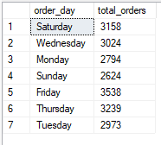

**hourly trend for pizza orders**

SELECT DATEPART(hour, order_time) AS sales_hours, COUNT(DISTINCT order_id) AS total_orders FROM pizza_sales

GROUP BY DATEPART(hour, order_time)

ORDER BY DATEPART(hour, order_time);

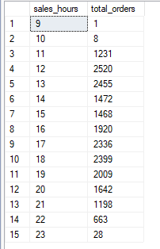

**% of sales per pizza category**

SELECT pizza_category, CAST(SUM(total_price) AS DECIMAL(10,2)) AS total_revenue,

CAST(SUM(total_price) * 100 / (SELECT SUM(total_price) FROM pizza_sales) AS DECIMAL(10,2)) AS PCT

FROM pizza_sales

GROUP BY pizza_category

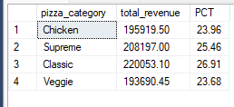

**% of sales per pizza size**

SELECT pizza_size, CAST(SUM(total_price) AS DECIMAL(10,2)) AS total_revenue,

CAST(SUM(total_price) * 100 / (SELECT SUM(total_price) FROM pizza_sales) AS DECIMAL(10,2)) AS PCT

FROM pizza_sales

GROUP BY pizza_size

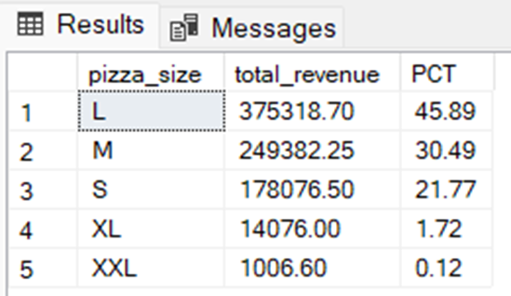

**Total pizza sold by category**

SELECT pizza_category ,SUM(quantity) AS Total_pizza_sold FROM pizza_sales

GROUP BY pizza_category

ORDER By SUM(quantity) DESC

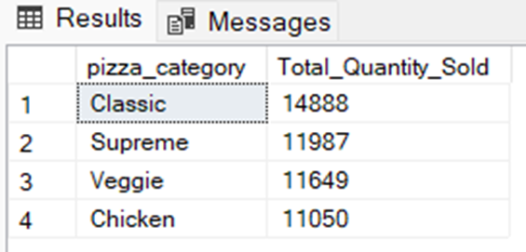

**Top 5 pizza sales by name**

SELECT TOP 5 pizza_name ,SUM(quantity) AS Total_pizza_sold FROM pizza_sales

GROUP BY pizza_name

ORDER By SUM(quantity) DESC

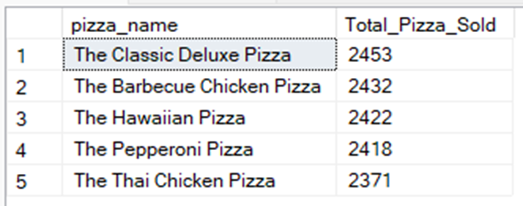

**Bottom 5 pizza sales by name**

SELECT TOP 5 pizza_name ,SUM(quantity) AS Total_pizza_sold FROM pizza_sales

GROUP BY pizza_name

ORDER By SUM(quantity) ASC

